Project Design Phase-II

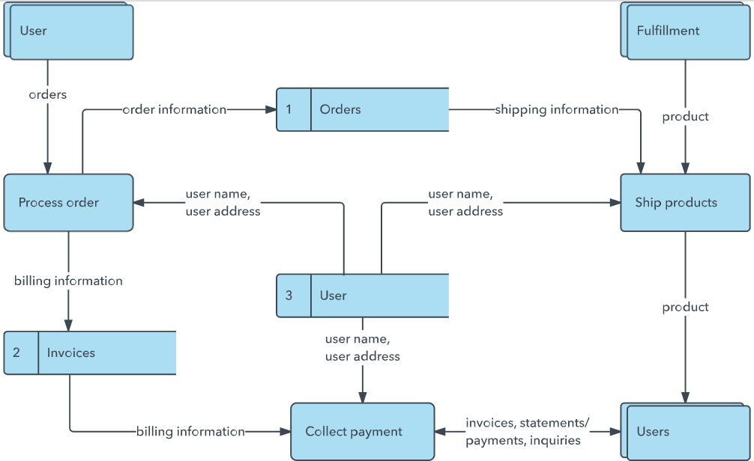

Data Flow Diagram & User Stories

|  |  |
| --- | --- |
| Date | 24 June 2025 |
| Team ID | LTVIP2025TMID59024 |
| Project Name | Flight finder-navigating your air travel options |
| Maximum Marks | 4 Marks |

# Data Flow Diagrams:

A Data Flow Diagram (DFD) is a traditional visual representation of the information flows within a system. A neat and clear DFD can depict the right amount of the system requirement graphically. It shows how data enters and leaves the system, what changes the information, and where data is stored.

Example: DFD Level 0 (Industry Standard)

# Example: [(Simplified)](https://developer.ibm.com/patterns/visualize-unstructured-text/)

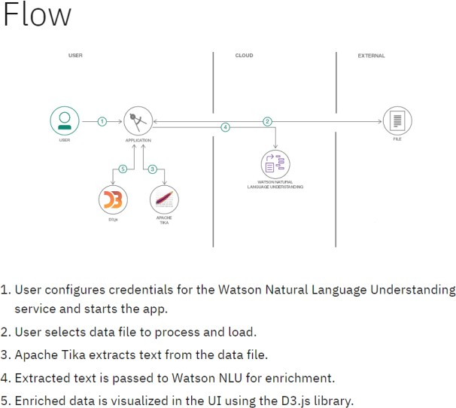

**User Stories**

Use the below template to list all the user stories for the product.

|  |  |  |  |  |  |  |
| --- | --- | --- | --- | --- | --- | --- |
| **User Type** | **Functional**  **Requirement (Epic)** | **User Story Number** | **User Story / Task** | **Acceptance criteria** | **Priority** | **Release** |
| Customer (Mobile user) | Registration | USN-1 | As a user, I can register for the application by entering my email, password, and confirming my password. | I can access my account / dashboard | High | Sprint-1 |
| Customer (Mobile user) | Registration | USN-2 | As a user, I will receive confirmation email once I have registered for the application | I can receive confirmation email & click confirm | High | Sprint-1 |
| Customer (Mobile user) | Login | USN-3 | As a user, I can register for the application through Facebook | I can register & access the dashboard with Facebook Login | Low | Sprint-2 |
| Customer (Mobile user) | Dashboard | USN-4 | As a user, I can register for the application through Gmail | Flights are shown in an organized layout | Medium | Sprint-1 |
| Customer (Mobile user) | Dashboard | USN-5 | As a user, I can log into the application by entering email & password | Search results are displayed as per criteria | High | Sprint-1 |
| Customer (mobile user) | Dashboard | USN-6 | As a user, I can view details of selected flights from the list | Flight detail page loads with complete information | Medium | Sprint-2 |
|  |  |  |  |  |  |  |
|  |  |  |  |  |  |  |
|  |  |  |  |  |  |  |